Software Specification

For

A Client Onboarding and Management System

Prepared by Kirubel Temesgen

26/01/2024

**Table of Contents**

**1. Introduction 3**

1.1 Purpose 3

1.2 Customers 3

1.3 Project Scope 3

**2. Overall Description 4**

2.1 System Features 4

2.2 Use Cases 4

2.3 Operating Environment 5

**3. System Features 6**

3.1 System Features Summary 6

3.2 Non-Functional Requirements 8

3.3 Functional Requirements 8

3.4 References 8

# **1.** ***Introduction***

## **1.1** Purpose

The goal of this project is to develop a web application for managing client onboarding processes, whilst also using real time analytics to enhance potential outputs. The application will focus on improving efficiency and organisation in handling client interactions. Key features will include streamlined onboarding processes, a user-friendly interface for managing tasks and multiple analytic tools. The objective is to create a practical solution for businesses to enhance their client management procedures.

## 1.2 Customers

The customers for this project will primarily consist of businesses seeking to streamline their client onboarding and management processes. Many of these businesses operate in the marketing sector and rely heavily on analytics to drive their operations. Therefore, the target customers will include marketing agencies, social media management firms, and similar entities that handle client engagements and require efficient tools for managing client interactions. Additionally, businesses across various industries that prioritise client management and seek to enhance their operational efficiency may also benefit from this software solution.

## 1.3 Project Scope

The project aims to develop a web application for managing client onboarding processes in businesses, with a focus on improving efficiency and organisation. It will include features such as streamlined onboarding processes, centralisation of client data, task management, and basic analytics functionalities.

# **2.** ***Overall Description***

## 2.1 System Features

**Use Case Diagram- Representing the main functionalities.**

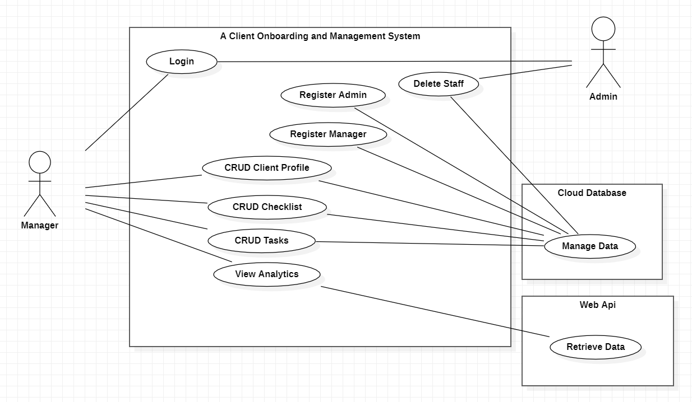

## 2.2 Use Cases

**1)** **Use Case: Manage Data in the Cloud Database**

Actors: Manager

Description:

The Manager actor can perform CRUD (Create, Read, Update, Delete) operations on client profiles, tasks, and checklists. These actions involve managing data stored in the cloud database. The use case holds the following functionalities:

* Create, Read, Update, and Delete client profiles.
* Create, Read, Update, and Delete tasks.
* Create, Read, Update, and Delete checklists.

Upon request of one of the following options the data is then created, received, updated or deleted in the cloud database.

**2)** **Use Case: Register Manager**

Actors: Admin, Manager

Description: A user requests to register a new Manager in the system on the opening page by clicking register Manager. The system generates a new ID for that manager. The manager enters their full name and then the Admin ID is used to manually verify this creation by the admin. The manager's details are stored in the cloud database. The manager can then login using their ID alone. This data is sent to the cloud database.

**3)** **Use Case: View Analytics**

Actor: Manager

Description: The Manager retrieves analytics data by clicking to view analytics on a specific client, from external sources via the web API which is presented visually.

**4) Use case: Register Admin**

Actor: Admin

Description: An admin can be registered on the opening page by clicking the register admin button. Upon request an admin will be asked for an email and full name for verification purposes. This info will be sent to the cloud database.

**5) Use case: Manage Staff**

Actor: Admin

Description: An Admin once logged in will be presented with a list of Managers and Admins. The Admin will select one of the Manager’s or Admin’s and confirm the deletion of the selected Manager or Admin, which will be updated in the cloud database.

## 2.3 Operating Environment

The website will operate in a cloud-based environment to ensure scalability and accessibility. The following components will be implemented for relatively easy access.

**Hardware Platform**: The website will be hosted on a cloud-based server infrastructure provided by PythonAnwhere, which insists the project will be built mainly on Python Frameworks. The server resources will be scalable based on demand to accommodate varying levels of traffic. MariaDB will be used as the database management system to store and manage the project's data efficiently and securely.

**Compatibility**: The website will be designed to be compatible with some modern web browsers, including Google Chrome and Mozilla Firefox.

# **3.** ***System Features***

The system enables secure client registration, task management, and centralised data storage. Real-time analytics provide insights, while scalability ensures adaptability to growing demands. With a focus on performance and efficiency, the system offers a no-brainer solution for businesses to enhance client interactions. Below are the main objects in this application.

**Class Diagram- Highlighting the relationships between Objects.**

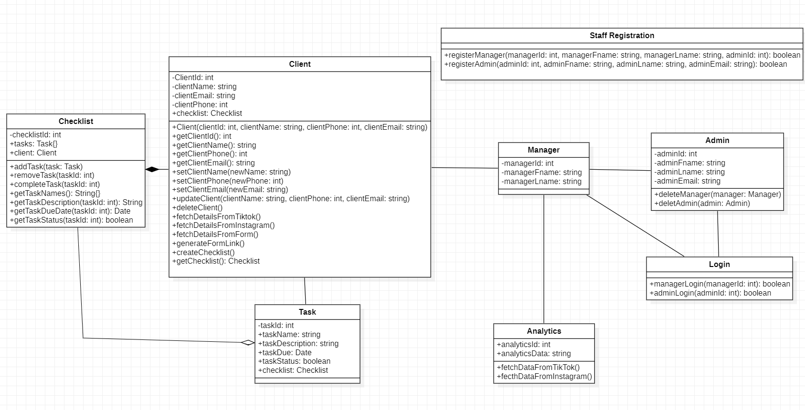

## 3.1 *System Features Summary*

1) **Streamlined Client Onboarding**: The application provides a streamlined process for onboarding new clients, facilitating the capture of client information and the creation of client profiles.

2) **Centralised Client Data**: Clients' information is centralised within the system, allowing for efficient storage, retrieval, and management of client-related data.

3) **Task Managemen**t: Users can create, assign, and track tasks related to client management, ensuring organised and efficient task execution.

4) **Basic Analytics Functionalities**: The application includes basic analytics functionalities, such as tracking content views and audience engagements, providing insights for informed decision-making.

5) **User-Friendly Interface**: The system features a user-friendly interface for managing tasks and interacting with client data, enhancing usability and user experience.

**Sequence Diagram – Showing the flow and control of objects.**

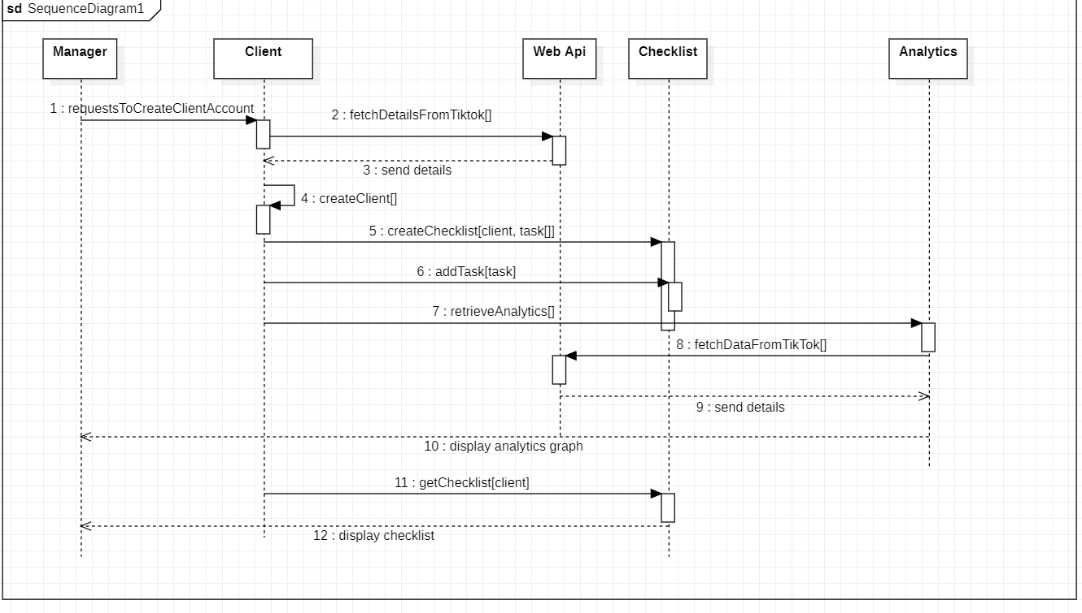

## 3.2 Non-Functional Requirements

1) **Performance**: The system should respond to user actions within a reasonable time frame, with minimal latency.

2) **Usability**: The system should have an intuitive user interface, with clear navigation and informative error messages.

3) **Scalability**: The system should be able to accommodate an increasing number of users and data volume as the project progresses.

## 3.3 Functional Requirements

1) **Manager Login**: Managers should be able to login using their ID.

2) **Client Onboarding**: The system should facilitate the onboarding process for clients, including capturing basic information and creating client profiles.

3) **Data Management**: Managers should be able to CRUD tasks, checklists and data related to client management.

4) **Analytics**: Basic analytics functionalities should be provided, such as tracking content views and audience engagements.

5) **Register Manager**: A user can register a Manager on the opening page of the system.

6) **Register Admin**: A user can register an Admin on the opening page of the system.

7) **Manage Staff**: Admins should be able to delete Admins and Managers.

8) **Admin Login**: Admins should be able to login using their ID.

## 

## 

## 

## **3.4 References**

* Admin@relevant.software (2023) *Your guide to writing a Software Requirements Specification (SRS) document*, *Relevant Software*. Available at: <https://relevant.software/blog/software-requirements-specification-srs-document/>

(Accessed: 25 January 2024).

* Lane, G.K. (no date) *HOW TO WRITE A software requirements specification (SRS document)*, *Perforce Software*. Available at: <https://www.perforce.com/blog/alm/how-write-software-requirements-specification-srs-document#:~:text=A%20software%20requirements%20specification%20(SRS)%20is%20a%20document%20that%20describes,stakeholders%20(business%2C%20users)>

(Accessed: 25 January 2024).

* Taaffe, Ed (2023) *Software requirements specification*, *Wikipedia*. Available at: <https://en.wikipedia.org/wiki/Software_requirements_specification>

(Accessed: 28 January 2024).

* *Exinfm*. Available at: <https://exinfm.com/training/M2C3/srs_template.doc>

(Accessed: 24 January 2024).

* Meudec, C. (2014) *Chris Meudec’s lean and agile UML reference*, *Google Docs*. Available at: <https://docs.google.com/document/d/1n0qvU3aGEct6IuW_VS8sZYSqF5G9TtaqNLvHK6nbKKA/edit#heading=h.s31dqr5jwul1>

(Accessed: 24 January 2024).

## 